Suffix

What is Suffix
# Source: Chatgpt (GPT-4-turbo) at [7/29/2025]
A suffix is a type of affix that is added to the end of a root or base word to form a new word or modify its grammatical function. Suffixes are very common in English and serve both derivational and inflectional purposes.

🔹 Definition of Suffix:
# Source: Chatgpt (GPT-4-turbo) at [7/29/2025]
A suffix is a bound morpheme attached to the end of a word root or stem. It cannot stand alone and is used to change the meaning, grammatical category, or function of a word.

🔹 Types of Suffixes:

1. Derivational Suffixes
# Source: Chatgpt (GPT-4-turbo) at [7/29/2025]
- Change the meaning or word class (part of speech).
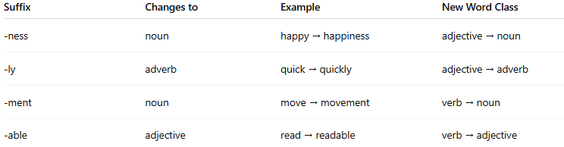
Suffix | Changes to | Example | New Word Class
-ness | noun | happy → happiness | adjective → noun
-ly | adverb | quick → quickly | adjective → adverb
-ment | noun | move → movement | verb → noun
-able | adjective | read → readable | verb → adjective

2. Inflectional Suffixes
# Source: Chatgpt (GPT-4-turbo) at [7/29/2025]
- Modify the word’s tense, number, comparison, or possession without changing its class.
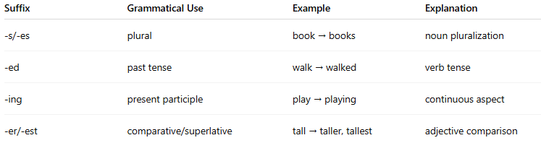
Suffix | Grammatical Use | Example | Explanation
-s/-es | plural | book → books | noun pluralization
-ed | past tense | walk → walked | verb tense
-ing | present participle | play → playing | continuous aspect
-er/-est | comparative/superlative | tall → taller, tallest | adjective comparison

🔹 Features of Suffixes:
# Source: Chatgpt (GPT-4-turbo) at [7/29/2025]
- ✅ Appear at the end of the root or stem.
- ✅ Can be derivational or inflectional.
- ✅ Common in word formation and grammatical modification.
- ❌ Cannot stand alone (they are bound morphemes).
- ✅ Frequently used in English and many other languages.

🔹 Suffix vs Other Affixes:
# Source: Chatgpt (GPT-4-turbo) at [7/29/2025]
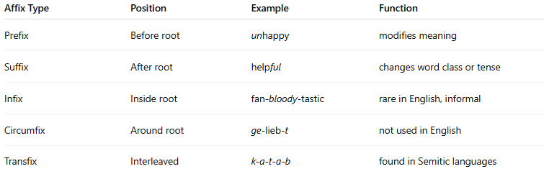
Affix Type | Position | Example | Function
Prefix | Before root | unhappy | modifies meaning
Suffix | After root | helpful | changes word class or tense
Infix | Inside root | fan-bloody-tastic | rare in English, informal
Circumfix | Around root | ge-lieb-t | not used in English
Transfix | Interleaved | k-a-t-a-b | found in Semitic languages

